# Business

**Upload the solution, without images!**

Create a Web page (HTML5 + CSS3 + images) that looks and behaves like the screenshot below:

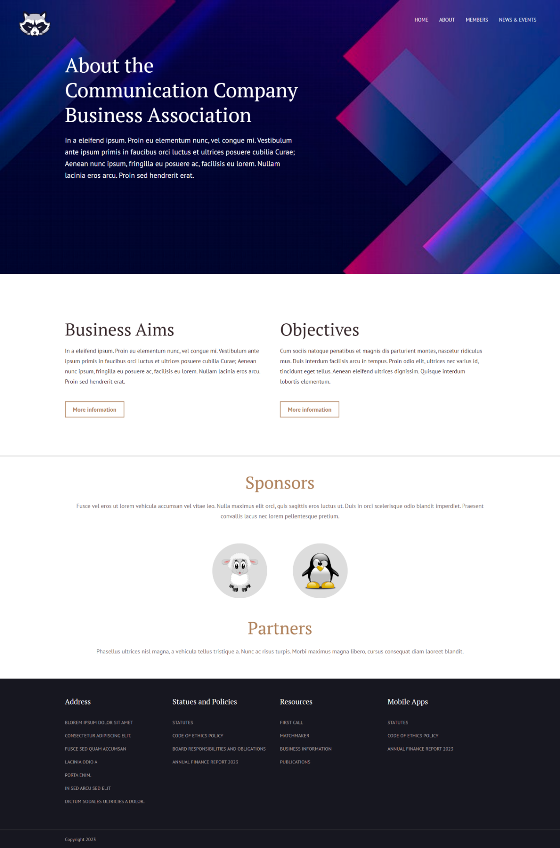

You are given the above screenshots + all required images.

## Output

The output should be valid **HTML5** + **CSS3** + **images** that implement the above web page.

## Constraints

* Use both fonts (**PT Serif** and **PT Sans**):
  + **https://fonts.googleapis.com/css?family=PT+Serif**
  + **https://fonts.googleapis.com/css?family=PT+Sans:400,700**
* The site should open correctly in the latest version of Chrome.